**Experiment 2.1**

**1) Check if number is positive,negative or zero.**

**CODE :**

num = float(input("Enter a number: "))

if num > 0:

print("Positive number")

elif num == 0:

print("Zero")

else:

print("Negative number")

**OUTPUT:**



**2) Check if number is odd or even**

**CODE :**

if num%2==0 :

print("EVEN NUMBER")

else :

print("ODD NUMBER")

**OUTPUT:**



**3) Check Leap Year**

**CODE :**

year=int(input("ENTER THE YEAR: "))

if (year%400==0):

print("LEAP YEAR")

elif(year%4==0) :

print("LEAP YEAR")

elif(year%100==0):

print(" NOT A LEAP YEAR")

else:

print(" NOT A LEAP YEAR")

**OUTPUT:**



**4) Find Largest of 3 numbers**

**CODE :**

num1=int(input("ENTER FIRST NUMBER : "))

num2=int(input("ENTER SECOND NUMBER : "))

num3=int(input("ENTER THIRD NUMBER : "))

largest =num1

if (num2 > largest) :

largest=num2

elif (num3 > largest) :

largest=num3

**OUTPUT:**

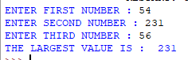

**5) To check Prime Number**

**CODE :**

num = int(input("Enter a number: "))

if num > 1:

for i in range(2,num):

if (num % i) == 0:

print(num,"is not a prime number")

break

else:

print(num,"is a prime number")

else:

print(num,"is not a prime number")

**OUTPUT :**

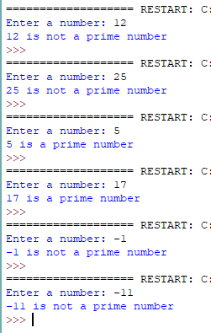

**6) To print all prime numbers in an interval**

**CODE :**

a=int(input("ENTER THE START OF THE INTERVAL: "))

b=int(input("ENTER THE END OF THE INTERVAL; "))

for num in range(a,b+1) :

for i in range(2,num):

if(num%2)== 0:

break;

else:

print(num)

**OUTPUT:**

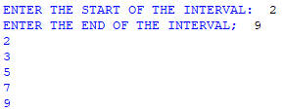

**7) Find factorial of a number**

**CODE :**

num=int(input("ENTER NUMBER : "))

fact=1

for i in range(1,num+1):

fact=fact*i

print("FACTORIAL OF A NUMBER IS : ",fact)

**OUTPUT:**



**8) Display multiplication table**

**CODE :**

num=int(input("ENTER NUMBER TO DISPLAY ITS MULTIPLICATION TABLE : "))

for i in range(1,13):

print(num ,"*" ,i ,"=",num*i)

**OUTPUT:**

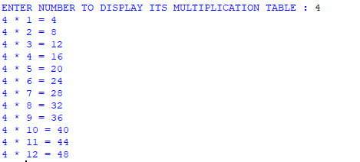

**9) Print fibonacci sequence**

**CODE :**

num=int(input("ENTER NUMBER OF ELEMENTS OF FIBONACCI SEQUENCE : "))

a=1

b=1

print("FIBONACCI SERIES IS : ")

print(a,end=" ")

print(b,end=" ")

for i in range(0,num-1):

c=a+b

print(c,end=" ")

a=b

b=c

**OUTPUT:**



**10) To check Armstrong Number**

**CODE :**

num = int(input("Enter a number: "))

sum = 0

temp = num

while temp > 0:

digit = temp % 10

sum += digit ** 3

temp //= 10

if num == sum:

print(num,"is an Armstrong number")

else:

print(num,"is not an Armstrong number")

**OUTPUT :**

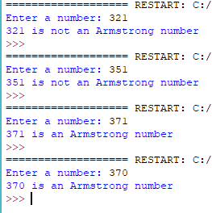

**11) Find armstrong number in an interval**

**CODE :**

a=int(input("ENTER THE START OF THE INTERVAL: "))

b=int(input("ENTER THE END OF THE INTERVAL; "))

for num in range(a, b + 1):

sum = 0

t = num

while num> 0 :

digit = num % 10

sum = sum+digit*digit*digit

num = num// 10

if t == sum:

print(sum)

**OUTPUT:**

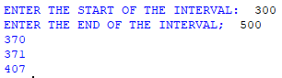

**12) Find sum of natural numbers**

**CODE :**

n=int(input("ENTER TOTAL NATURAL NUMBERS: "))

sum=0

for i in range(1,n+1) :

sum=sum+i

print("SUM OF NATURAL NUMBERS IS : ",sum)

**OUTPUT:**

